**Deerwalk Institute Of Technology**

**Internet Technology**

**Submitted By: Submitted To:**

**Name: Sagar Giri Sudhir Maharjan**

**Roll No. 205**

**Date: July 15th 2016**

**IPv4 and subnet**

IP address is a unique string of numbers separated by full stops that identifies each computer using the Internet Protocol to communicate over a network. Traditionally, for several decades IP address were divided into five categories as per classful addressing namely class A, B, C, D, and E. Network numbers are managed by ICANN (Internet Corporation for Assigned Names and Numbers) to avoid the conflict.

To implement subnetting, the main router needs subnet mask that indicates split between network subnet number and host. Subnet mask are also written in dotted decimal notation, with the addition of slash '/' followed by number of bits in network and subnet part.

For Example:

192.168.1.0/28 network means 28 bits are used for network and rest four bits used for host.

Subnetting Example:

Let us assume that we have only one IP address as 192.168.1.0. Now, we have to divide this IP address among the sub-network consisting of 8, 4, and 13 hosts respectively. Connection between two routers act as a sub network with two hosts. So, there are total of five sub-network in whole network.

Maximum number of host in single subnetwork = 13

So, total bits to allocate for hosts = 2ⁿ where (n = number of bits)

so, network masking = /28 (i.e. 28 bits for network )

subnet mask = 255.255.255.240

Available IPs are 192.168.1.1 – 192.168.1.14 (14 IP addresses available with one waste)

Similarly,

Maximum number of host in single subnetwork = 8

So, total bits to allocate for hosts = 2ⁿ where n = number of bits= 4 (two IP addresses cannot be used as it is used for multicast and other purpose)

so, network masking = /28 (i.e. 28 bits for network )

subnet mask = 255.255.255.240

Available Ips are 192.168.1.17 – 192.168.1.30 (14 IP addresses available with six waste)

Maximum number of host in single subnetwork = 4

So, total bits to allocate for hosts = 2ⁿ where n = number of bits= 3

so, network masking = /29 (i.e. 29 bits for network )

subnet mask = 255.255.255.248

Available Ips are 192.168.1.33 – 192.168.1.39 (7 IP addresses available with three waste)

Maximum number of host in single subnetwork = 2

So, total bits to allocate for hosts = 2ⁿ where n = number of bits= 2

so, network masking = /30 (i.e. 30 bits for network )

subnet mask = 255.255.255.252

Available Ips are 192.168.1.41 – 192.168.1.42 (2 IP addresses available)

Maximum number of host in single subnetwork = 2

So, total bits to allocate for hosts = 2ⁿ where n = number of bits= 2

so, network masking = /30 (i.e. 30 bits for network )

subnet mask = 255.255.255.252

Available Ips are 192.168.1.45 – 192.168.1.46 (2 IP addresses available)

The IPV4 and subneting is implemented in Cisco Packet Tracer and it’s output is as follows:

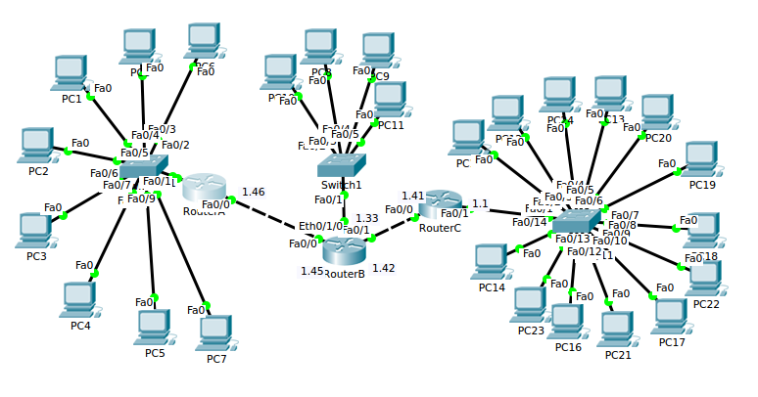

**Fig: Network containing five sub-network with 13, 8,4, 2, and 2 hosts respectively.**

In IPV4 an address consists of 32 bits which limits the address space to 4294967296 ( 2ⁿ where n=32) possible unique addresses. IPv4 reserves some addresses for special purposes such as private networks (~18 million addresses) or multicast addresses (~270 million addresses).

IPv4 addresses are canonically represented in dot-decimal notation, which consists of four decimal numbers, each ranging from 0 – 255, separated by dots, eg., 192.168.1.0. Each part represents a group of 8 bits (octet) of the address. In some cases of writing, IPv4 addresses may be presented in various hexadecimal, octal, or binary representations.